SIMATS ENGINEERING
SAVEETHA INSTITUTE OF MEDICAL AND TECHNICAL SCIENCES
CHENNAI – 602105
Department of Computer Science and Engineering

ASSESSMENT TOOL 3 – Visualization Design Activity

Course Code: | DSA0502 | Course Title: | Query Processing for Data Science
CO Assessed: | CO5 | Assessment: | Tool 3– Visualization Design Activity
Weightage: | 35% | Total Marks:
CO5 Statement: Create meaningful visualizations using Pandas and Matplotlib, including charts, distributions, relationships, and interactive visual representations for effective communication
Student Name: | K. V. Sai. Shanmukh | Reg. No.: | 192424306
Section / Batch: | BTECH- AI& DS | Date of Submission: | 20/08/2026
Faculty In-charge: | Dr. B. Shyamala Gowri | Project Mode: | Individual Submission

Code of Conduct
I _K. V. Sai. Shanmukh(192424306)_ (Name / Reg No) certifies that this submission is my original work and that I have adhered to all guidelines specified for this assessment. I understand that any violation of academic integrity rules will result in disciplinary action.
Signature: _____K V Sai Shanmukh____

3. Compare Plot Types
Use the same dataset to create a line plot, bar plot and scatter plot. Discuss which plot communicates the data most effectively.
1. Line Plot
- Connect data points using lines.
- Useful for showing trends or changes.
- Here, it shows how marks change from Student A to E.
2. Bar Plot
- Represents each student using a bar.
- Useful for comparing individual values.
- We can easily see which student has higher or lower marks.
3. Scatter Plot
- Represents each observation as a point.
- Useful for finding the relationship between two numerical variables.
- Here, it shows the relationship between study hours and marks.

Plot | Best Used For | Interpretation
Line Plot | Trends | Shows change in marks
Bar Plot | Comparison | Clearly compares student marks
Scatter Plot | Relationship | Shows study hours vs marks
Code:
import pandas as pd
import matplotlib.pyplot as plt
import os
file_path = "/content/employee_salary_dataset.csv"
if not os.path.exists(file_path):
print(f"Error: The file {file_path} was not found.")
else:
df_salary = pd.read_csv(file_path)
print("### Dataset Head ###")
display(df_salary.head())
print("\n### Dataset Information ###")
df_salary.info()
plt.figure(figsize=(12, 6))
plt.plot(df_ts.index, df_ts['Monthly_Salary'], marker='o', linestyle='-')
plt.title('Monthly Salary Over Time (Line Plot)')
plt.xlabel('Date')
plt.ylabel('Monthly Salary')
plt.grid(True)
plt.xticks(rotation=45)
plt.tight_layout()
plt.show()
plt.figure(figsize=(12, 6))
plt.bar(df_ts.index, df_ts['Monthly_Salary'], width=20) # Adjust width for monthly data
plt.title('Monthly Salary Over Time (Bar Plot)')
plt.xlabel('Date')
plt.ylabel('Monthly Salary')
plt.grid(axis='y')
plt.xticks(rotation=45)
plt.tight_layout()
plt.show()

plt.figure(figsize=(12, 6))
plt.scatter(df_ts.index, df_ts['Monthly_Salary'])
plt.title('Monthly Salary Over Time (Scatter Plot)')
plt.xlabel('Date')
plt.ylabel('Monthly Salary')
plt.grid(True)
plt.xticks(rotation=45)
plt.tight_layout()
plt.show()
Output:
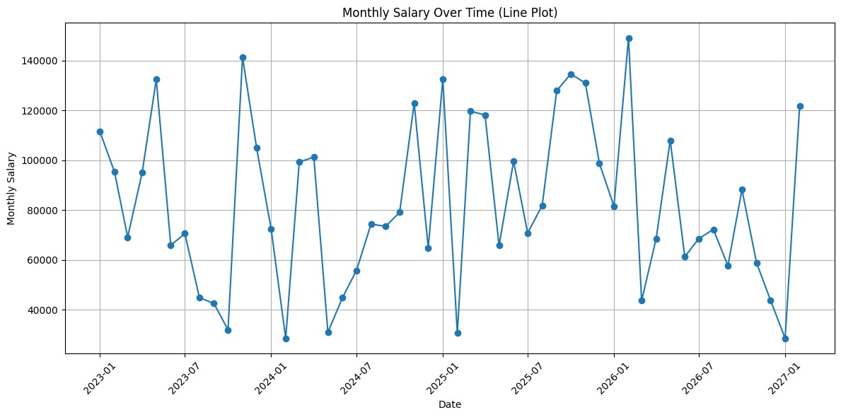
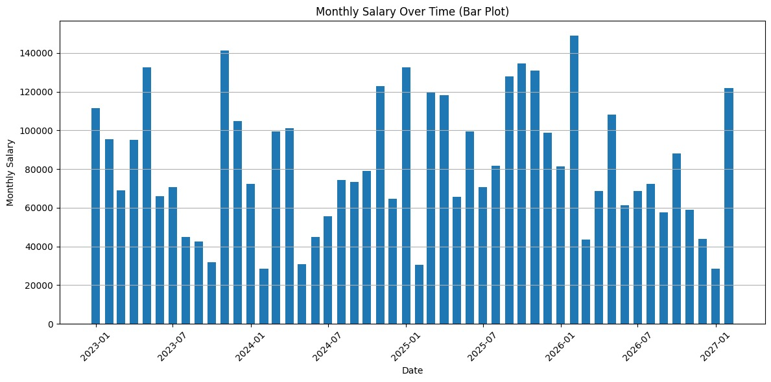
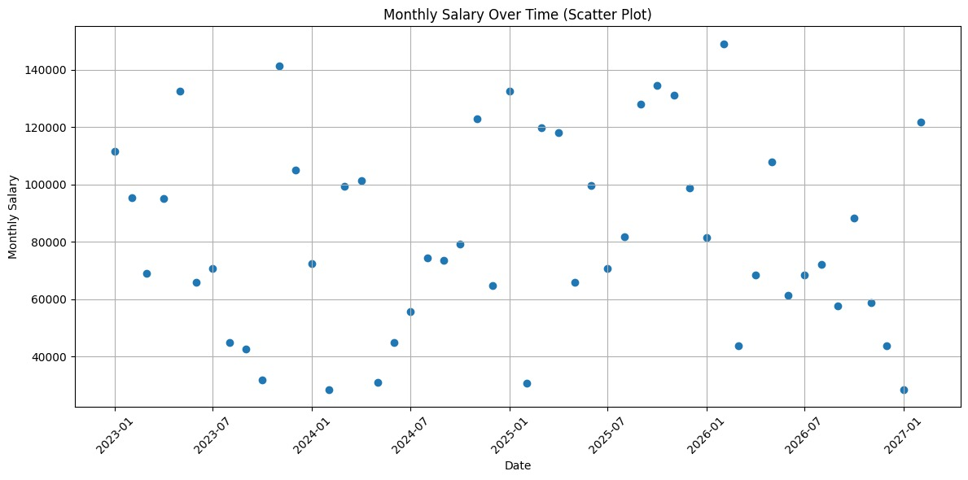

11. Autocorrelation Analysis
Generate an autocorrelation plot for a time series. Identify lags with relatively strong positive or negative autocorrelation.
What is Autocorrelation?
Autocorrelation measures how similar a time series is to its previous values at different time lags.
For example:
- Lag 1 → Compare today's value with yesterday's value.
- Lag 2 → Compare today's value with the value two periods ago.
- Lag 3 → Compare today's value with the value three periods ago.
How to Interpret the Plot
The important part is the autocorrelation value at each lag.
- Autocorrelation close to +1 → strong positive relationship.
- Autocorrelation close to 0 → weak or no relationship.
- Autocorrelation close to −1 → strong negative relationship.

For example:

Lag | Interpretation
1 | Strong positive autocorrelation
2 | Positive autocorrelation
3 | Moderate positive autocorrelation
4 | Weaker autocorrelation
Higher lags | Usually decreasing autocorrelation
Because the sample data has a gradually increasing pattern, nearby observations tend to be similar. Therefore, the early lags show relatively strong positive autocorrelation.

Code:
import pandas as pd
import matplotlib.pyplot as plt
from statsmodels.graphics.tsaplots import plot_acf
import os
# File path
file_path = r"C:\Users\karan\OneDrive\Desktop\QUERY PROCESSING\employee_salary_dataset.csv"
# Check whether file exists
if not os.path.exists(file_path):
print(f"Error: The file {file_path} was not found.")
else:
# Read CSV file
df_salary = pd.read_csv(file_path)
print("### Dataset Head ###")
print(df_salary.head())
print("\n### Dataset Information ###")
df_salary.info()
# Column names
date_column_name = 'Date'
value_column_name = 'Monthly_Salary'
# Check Monthly_Salary column
if value_column_name in df_salary.columns:
# Create Date column if it doesn't exist
if date_column_name not in df_salary.columns:
df_salary[date_column_name] = pd.date_range(
start='2023-01-01',
periods=len(df_salary),
freq='MS'
)
print(f"\nCreated synthetic '{date_column_name}' column.")
# Set Date as index
df_salary.set_index(date_column_name, inplace=True)
# Sort by date
df_salary = df_salary.sort_index()
# Select salary column and remove missing values
df_ts = df_salary[[value_column_name]].dropna()
if not df_ts.empty:
# Calculate number of lags
num_lags = min(len(df_ts) // 2 - 1, 40)
if num_lags > 0:
# Create autocorrelation plot
fig, ax = plt.subplots(figsize=(12, 6))
plot_acf(
df_ts[value_column_name],
ax=ax,
lags=num_lags
)
ax.set_title(
f'Autocorrelation Plot for {value_column_name}'
)
ax.set_xlabel('Lags')
ax.set_ylabel('Autocorrelation')
plt.grid(True, linestyle='--', alpha=0.7)
plt.show()
# Calculate autocorrelation values
from statsmodels.tsa.stattools import acf
acf_values = acf(
df_ts[value_column_name],
nlags=num_lags
)
# Remove lag 0
acf_values = acf_values[1:]
# Find strong positive autocorrelation
significant_lags_positive = [
i + 1
for i, val in enumerate(acf_values)
if val > 0.5
]
# Find strong negative autocorrelation
significant_lags_negative = [
i + 1
for i, val in enumerate(acf_values)
if val < -0.5
]
print(
"\nLags with strong positive autocorrelation "
f"(value > 0.5): {significant_lags_positive}"
)
print(
"Lags with strong negative autocorrelation "
f"(value < -0.5): {significant_lags_negative}"
)
else:
print(
"Not enough data points to perform "
"autocorrelation analysis."
)
else:
print(
f"The '{value_column_name}' column is empty."
)
else:
print(
f"Error: Expected column '{value_column_name}' "
"not found in the dataset."
)
print(
"Please check the column name in your CSV file."
)
Output:
